HAPPY TO HELP GUIDE YOU IN YOUR NEXT REAL ESTATE ADVENTURE!
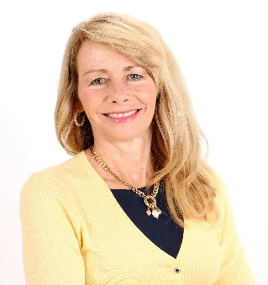
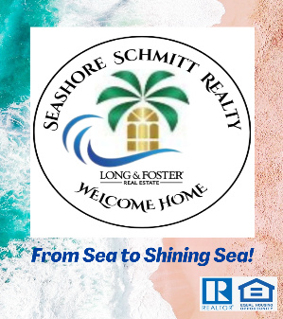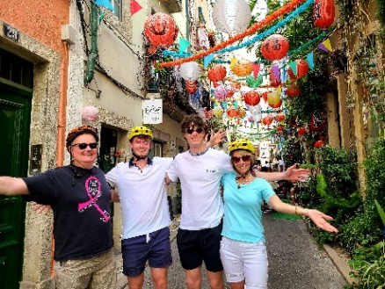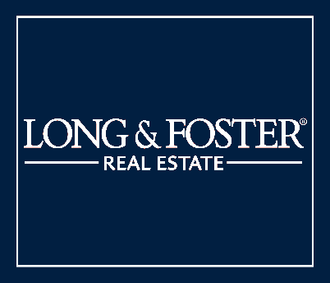
Kathryn Seashore Schmitt | Reston Office| cell: 703-980-7193 | email: Kathryn.Schmitt@LNF.com Why Me. Top 5 Reasons:
- MBA Finance & Investments; market expert
- Lifelong resident of Virginia; neighborhood expert
- Compassionate trusted advisor; your personal advocate with your best interests at heart
- Strategic: provide exceptional client service using exclusive buyer and seller services, top negotiation skills, delivering exceptional results
- One Stop Shopping, All Inclusive Model with #1 Real Estate firm, Long & Foster
As a real estate agent, I work and live for the love of home. I’m your trusted advisor, your practiced negotiator, your skilled house-hunter, your home decorator and stager, and your real estate market and neighborhood expert. As a VA native, I have an intimate knowledge of Virginia and the Washington, D.C. metropolitan area. Your home is not only a real estate investment and source of financial security, but also a place where special memories are made.
Working with me, you’ll also gain the expertise and backing of Long & Foster (L&F), the #1 local residential real estate company & leader in the industry for 55 years. We provide an exceptional client experience with one stop shopping - an all-inclusive ultimate team from Reston L&F Brokerage, Prosperity Home Mortgage, RGS Title and settlement, L&F Insurance, Tailored Move, Insights Home Inspections, Turnkey Listing Concierge by Curbio (refresh, renovations, remodels with no project minimum; fix now and pay at closing), and more.
Educated in the local VA/DC Metro area, happy to share my business acumen & wonderful community experience. As a graduate of W.T. Woodson High School in Fairfax, the University of Richmond (bachelor’s degree in finance), and George Washington University in D.C. (master’s in business administration (MBA) degree), I truly understand the financial and economic levers that drive the real estate market and how to position us well to maximize home value and enhance buyer purchasing power. Tech savvy with a strong digital presence, I can leverage digital technology and marketing tools to drive home sales.
Prior to pursuing a career in real estate, I led a successful career in management consulting, business operations, and business development acquiring skills that translate well into my real estate business. I am entrepreneurial, strategic, organized, a clear communicator, and enjoy partnering with others. Compassionate, friendly and results oriented, I bond easily with clients and am devoted to exceeding your real estate needs. I also enjoy serving my community as a Community Ambassador of the Children’s Science Center with plans underway to build a science museum in Loudoun County, with groundbreaking in 2024.
When not immersed in real estate, I enjoy traveling, experiencing new cultures, spending time with family and friends, and sailing locally on the Chesapeake Bay with my husband (& UR college sweetheart), Steve, of 33 years, and 2 wonderful sons. Ryan is a recent University of Virginia graduate with a degree in Cognitive Science & Neuroscience, Eagle Scout, and works for Pattern Data as an Artificial Intelligence Specialist. Cameron is a freshman at Clemson University, South Carolina, majoring in marketing and entrepreneurship, and an active athlete and Beta Theta Pi brother. We all enjoy our endearing golden retriever, Barkley.

